Name _______________________________ Date _____________ pd ___

Manifest Destiny and American Foreign Policy in the 1800s

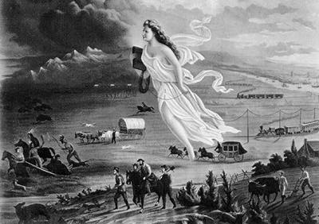

Look at the painting above. What do you notice about it?
________________________________________________________________________________________________________________________
________________________________________________________________________________________________________________________

What is Manifest Destiny?
________________________________________________________________________________________________________________________

Knowing about the idea of Manifest Destiny, what does the painting show?
________________________________________________________________________________________________________________________
________________________________________________________________________________________________________________________

The Monroe Doctrine is a policy of the United States introduced on December 2, 1823. It stated that further efforts by European nations to colonize land or interfere with states in North or South America would be viewed as acts of aggression requiring U.S. intervention. The Doctrine noted that the United States would neither interfere with existing European colonies nor meddle in the internal concerns of European countries. The Doctrine was issued at a time when nearly all Latin American colonies of Spain and Portugal had achieved independence from the Spanish Empire (except Peru and Bolivia, which became independent in 1825, and Cuba and Puerto Rico). The United States, working in agreement with Britain, wanted to guarantee no European power would move in.
President James Monroe first stated the doctrine during his seventh annual State of the Union Address to Congress. It became a defining moment in the foreign policy of the United States and one of its longest-standing tenets, and would be invoked by many U.S. statesmen and several U.S. presidents, including Theodore Roosevelt, John F. Kennedy, Ronald Reagan and others.
The intent and impact of the Monroe Doctrine persisted with only minor variations for almost two centuries. Its primary objective was to free the newly independent colonies of Latin America from European intervention and control that would make the New World a battleground for the Old. The doctrine put forward that the New World and the Old World were to remain distinctly separate spheres of influence, for they were composed of entirely separate and independent nations.

In your own words, what was the Monroe Doctrine?
________________________________________________________________________________________________________________________
________________________________________________________________________________________________________________________

Explain the connection between the American idea of Manifest Destiny and American foreign policy (Monroe Doctrine).
________________________________________________________________________________________________________________________
________________________________________________________________________________________________________________________

